**Design Thinking- A Comprehensive Guide**

**1. Introduction**

In a fast-paced, innovation-driven world, organizations face increasingly complex problems. Traditional linear problem-solving often fails to capture human needs or generate creative solutions. **Design Thinking** offers a structured, human-centered, and iterative approach that combines empathy, creativity, and rationality to solve problems effectively.

Organizations such as **IDEO, Google, Apple, IBM, and Stanford’s d.school** widely adopt Design Thinking to develop innovative products, services, and experiences that resonate with users.

**2. Definition of Design Thinking**

Design Thinking is a **human-centered methodology** for creative problem-solving that emphasizes:

* Understanding user needs,
* Reframing problems,
* Ideating solutions,
* Prototyping,
* Testing iteratively.

**Formal definitions:**

* **IDEO:** “Design Thinking is a human-centered approach to innovation integrating people’s needs, technological possibilities, and business viability.”
* **Stanford d.school:** “Design Thinking encourages organizations to focus on the people they’re creating for, leading to better products, services, and processes.”

In essence, Design Thinking transforms insights into actionable solutions by combining **empathy, creativity, and experimentation**.

**3. Core Principles of Design Thinking**

**3.1 Human-Centered Approach**

* Focus on real human needs rather than assumptions.
* Engage with users through interviews, observation, and immersion.
* Design solutions that truly address user pain points.

**3.2 Empathy**

* Understand users’ motivations, emotions, and challenges.
* Transform abstract data into actionable insights.
* Build trust and gain deeper understanding through observation and dialogue.

**3.3 Iterative Process**

* Design Thinking is **non-linear**.
* Ideas are refined through repeated cycles of prototyping and testing.
* Iteration reduces risk and enhances solution quality.

**3.4 Collaboration**

* Multidisciplinary teams bring diverse perspectives.
* Collaboration enhances creativity and prevents siloed thinking.
* Encourages communication and shared ownership of solutions.

**3.5 Prototyping and Experimentation**

* Rapid, low-cost prototypes allow quick feedback.
* Hands-on experimentation accelerates learning.
* Identifies usability issues early and fosters innovation.

**3.6 Bias Toward Action**

* Emphasis on learning through doing.
* Encourages early testing instead of over-analysis.
* Small, informed steps lead to faster progress.

**3.7 Problem Reframing**

* Focus on asking the right questions.
* Challenge assumptions and uncover hidden problems.
* Leads to innovative solutions that might otherwise be overlooked.

**3.8 Balancing Desirability, Feasibility, and Viability**

* **Desirability:** Will users want it?
* **Feasibility:** Can it be built with available technology?
* **Viability:** Is it economically sustainable?
* Ensures solutions are practical, innovative, and valuable.

**4. Phases of Design Thinking**

Design Thinking typically follows **five iterative phases**:

1. **Empathize**
   * Understand the users and their needs.
   * Tools: Observations, interviews, empathy maps, user journey maps.

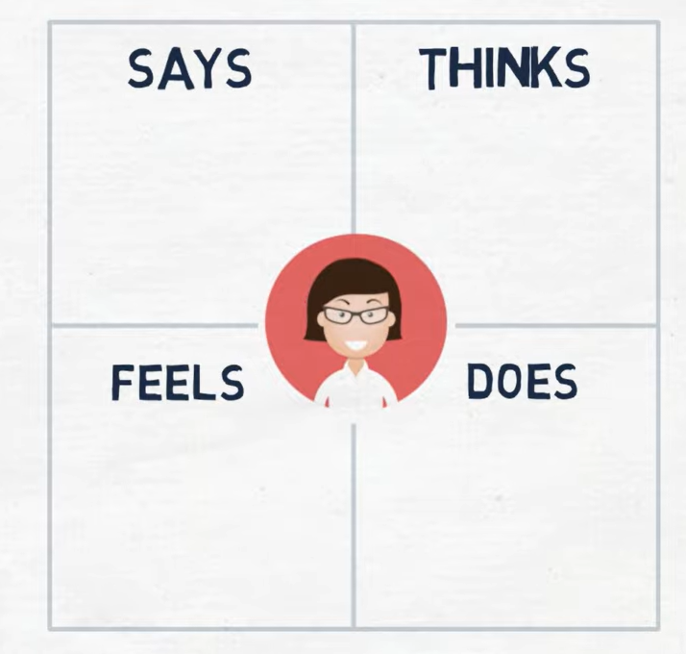

**Video Link:**

<https://www.youtube.com/watch?v=QwF9a56WFWA&t=43s>

1. **Define**
   * Clearly articulate the problem based on insights from empathy.
   * Tools: Problem statements, “How Might We” questions, point-of-view statements.
2. **Ideate**
   * Generate a broad range of creative ideas.
   * Tools: Brainstorming, mind mapping, SCAMPER, sketching.

Video Link:

<https://www.youtube.com/watch?v=WnbyZeKSXE4>

1. **Prototype**
   * Build low-fidelity representations of solutions.
   * Tools: Paper prototypes, wireframes, mockups, digital prototypes.

Video Link:

<https://www.youtube.com/watch?v=_n2C4m1hLHA&t=162s>

1. **Test**
   * Gather user feedback on prototypes.
   * Refine the solution based on results.
   * Tools: Usability testing, surveys, A/B testing, focus groups.

Note: These phases are **non-linear**. Teams may revisit earlier stages as new insights emerge.

**5. Tools and Techniques**

| **Phase** | **Common Tools & Techniques** |
| --- | --- |
| Empathize | User interviews, observation, empathy maps, personas |
| Define | Problem statements, “How Might We” questions, journey maps |
| Ideate | Brainstorming, mind maps, SCAMPER, storyboards |
| Prototype | Sketches, 3D models, wireframes, role-playing |
| Test | Feedback sessions, surveys, usability testing, analytics |

**6. Case Studies**

**6.1 IDEO Shopping Cart Redesign**

* Problem: Improve the shopping cart.
* Approach: IDEO conducted user observations, brainstormed creative solutions, prototyped multiple designs.
* Outcome: A redesigned cart that was safer, easier to maneuver, and more user-friendly.

**6.2 Airbnb**

* Problem: Low user engagement and poor occupancy.
* Approach: Found users’ needs via empathy research; redesigned the platform experience.
* Outcome: Enhanced listings, photos, and host interactions, leading to rapid growth.

**7. Benefits of Design Thinking**

* Encourages **innovation** and creative problem-solving.
* Enhances **user experience** and customer satisfaction.
* Reduces **development risks** by testing ideas early.
* Promotes **cross-functional collaboration**.
* Fosters a **culture of empathy, experimentation, and continuous learning**.

**8. Practical Exercises**

1. **Empathy Exercise:** Interview five users about a daily pain point and map their experience.
2. **Problem Reframing:** Take a common problem and rephrase it using “How Might We…” questions.
3. **Ideation Challenge:** Generate at least 20 potential solutions in 15 minutes.
4. **Prototype Rapidly:** Build a paper or digital prototype of one idea.
5. **Test & Iterate:** Get feedback from users and refine your solution.

**9. Conclusion**

Design Thinking is more than a methodology — it’s a **mindset** that prioritizes human needs, collaboration, and experimentation.

By following its principles and phases, organizations can develop innovative, feasible, and desirable solutions, leading to superior products, services, and user experiences.

“Design Thinking transforms the way we approach problems, shifting from solutions we think users want, to solutions they actually need.”